**Project Design Phase-II**

**Technology Stack (Architecture & Stack)**

**Technical Architecture:**

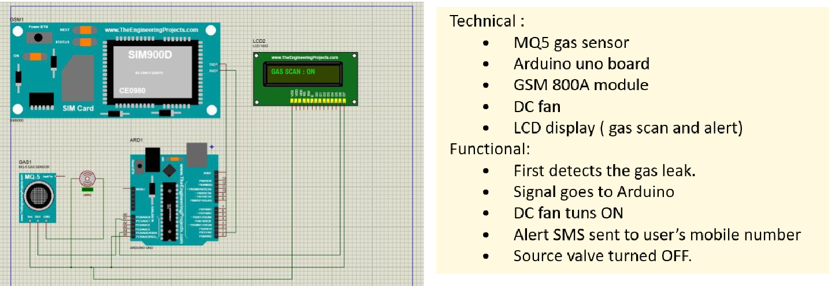

|  |  |
| --- | --- |
| Date | 03 October 2022 |
| Team ID | PNT2022TMID39018 |
| Project Name | Gas leakage monitoring and alerting system for industries |
| Maximun Marks | 4 Marks |

**DEVELOPMENT OF TASK ANALYSIS:**

**Hardware Requirements :**

1) Arduino UNO Microcontroller

2) Green LED 1, Red LED 3

3) 9V Power supply (230V TO 9V STEPDOWN TRANSFORMER)

4) MQ6 Gas sensor

5) GSM 800 Module

6) GSM Sim

7) Connecting wires

8) Project base

**Software Requirements** :

1) Arduino IDE

2) Language C++

**WORKING:**

Step 1: A signal from the microcontroller will go to the display and show gas leakage message there.

Step 2: Simultaneously automatically turns on the DC fan to ventilate the leaked gas, and the source solenoid valve will be turns off

Step 3: Signal from microcontroller activates the GSM module and sends an alert SMS “ALERT GAS LEAKING” to the user’s mobile number